**CETM46 Data Science Product Development**

**Software & Hardware Platforms Introduction**

**Task1 GIT Create git repo in your git account (25 Minutes)**

***Git*** *is a*[free and open source](https://git-scm.com/about/free-and-open-source) distributed version control system *designed to handle everything from small to very large projects with speed and efficiency.*

Install git:

<https://git-scm.com/>

Create repo

<https://git-scm.com/book/en/v2/Git-Basics-Getting-a-Git-Repository>

What is & how to create ReadMe file:

[https://gist.github.com/PurpleBooth/109311bb0361f32d87a2](https://mail.staff.sunderland.ac.uk/owa/redir.aspx?C=9meetl3jMHl8HiqUKyg3ZQfbY3RhtODG_tNQHihldwFF7XFsXmjXCA..&URL=https%2525253a%2525252f%2525252fgist.github.com%2525252fPurpleBooth%2525252f109311bb0361f32d87a2)

ReadMe file Example:

[https://github.com/coreui/coreui-free-bootstrap-admin-template/blob/master/README.md](https://mail.staff.sunderland.ac.uk/owa/redir.aspx?C=97AUypOqZ2wswD-3AA3w4hje1ONoaCDmh7yhG1U5K3hF7XFsXmjXCA..&URL=https%2525253a%2525252f%2525252fgithub.com%2525252fcoreui%2525252fcoreui-free-bootstrap-admin-template%2525252fblob%2525252fmaster%2525252fREADME.md)

Please, add me (account name: Luodina) to the list of collaborators at your repo via web-panel:

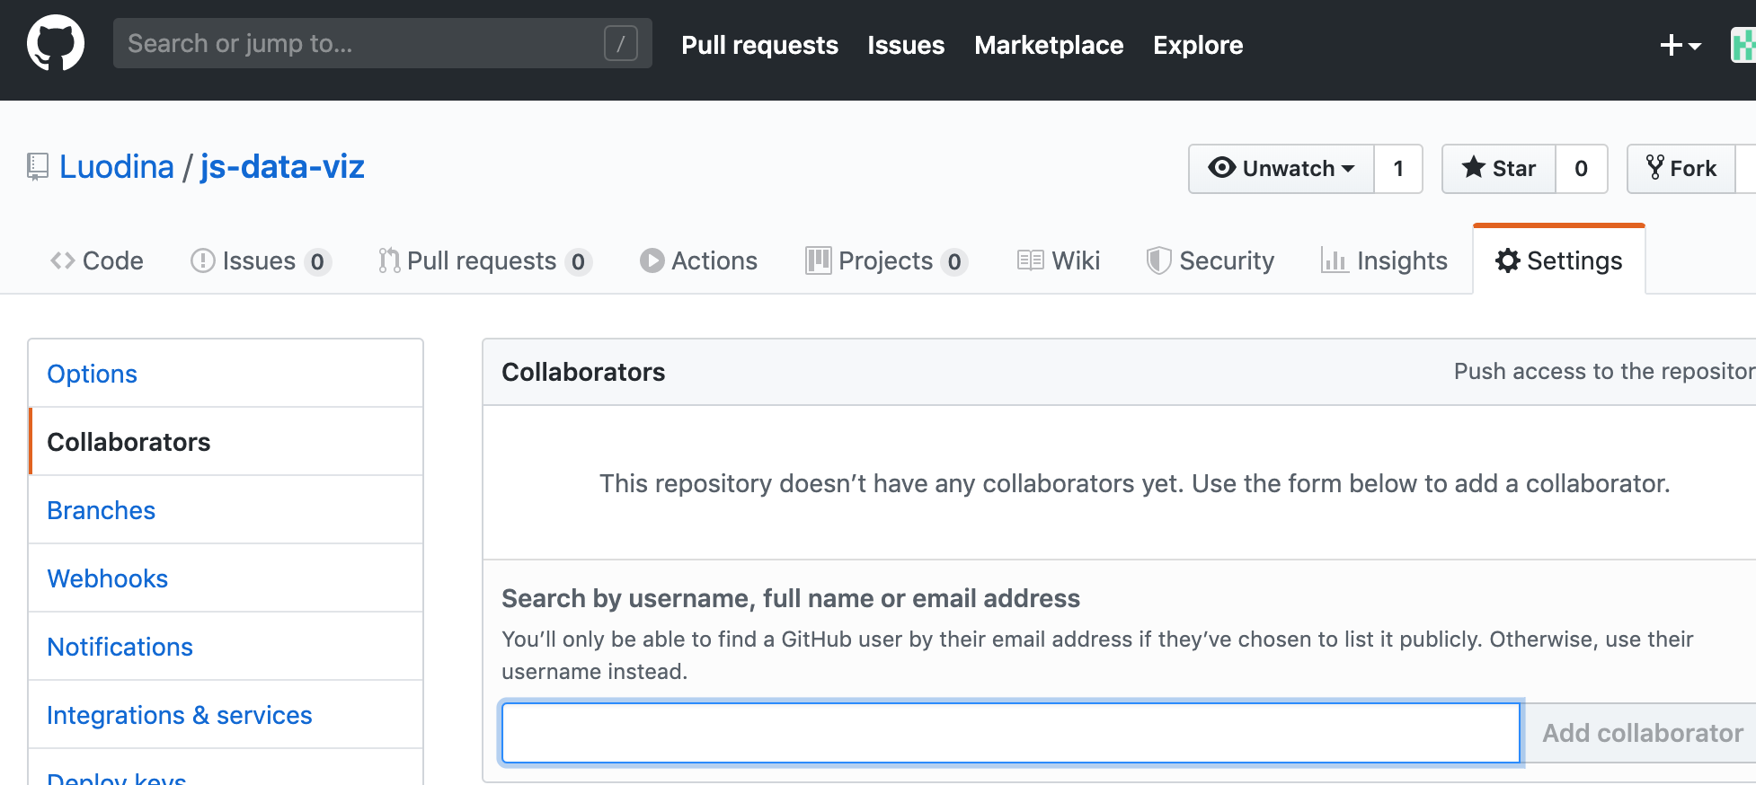

**Task2 Read the article (25 mins)**

**Data Viz tools:**

<https://towardsdatascience.com/9-data-visualization-tools-that-you-cannot-miss-in-2019-3ff23222a927>

**Data Science tools:**

<https://bigdata-madesimple.com/top-20-python-libraries-for-data-science/>

<https://data-flair.training/blogs/r-packages-for-data-science/>